Establishing Pollinator Habitats in Vegetative Filter Strips: A Sustainable Opportunity for Colorado Corn Farmers

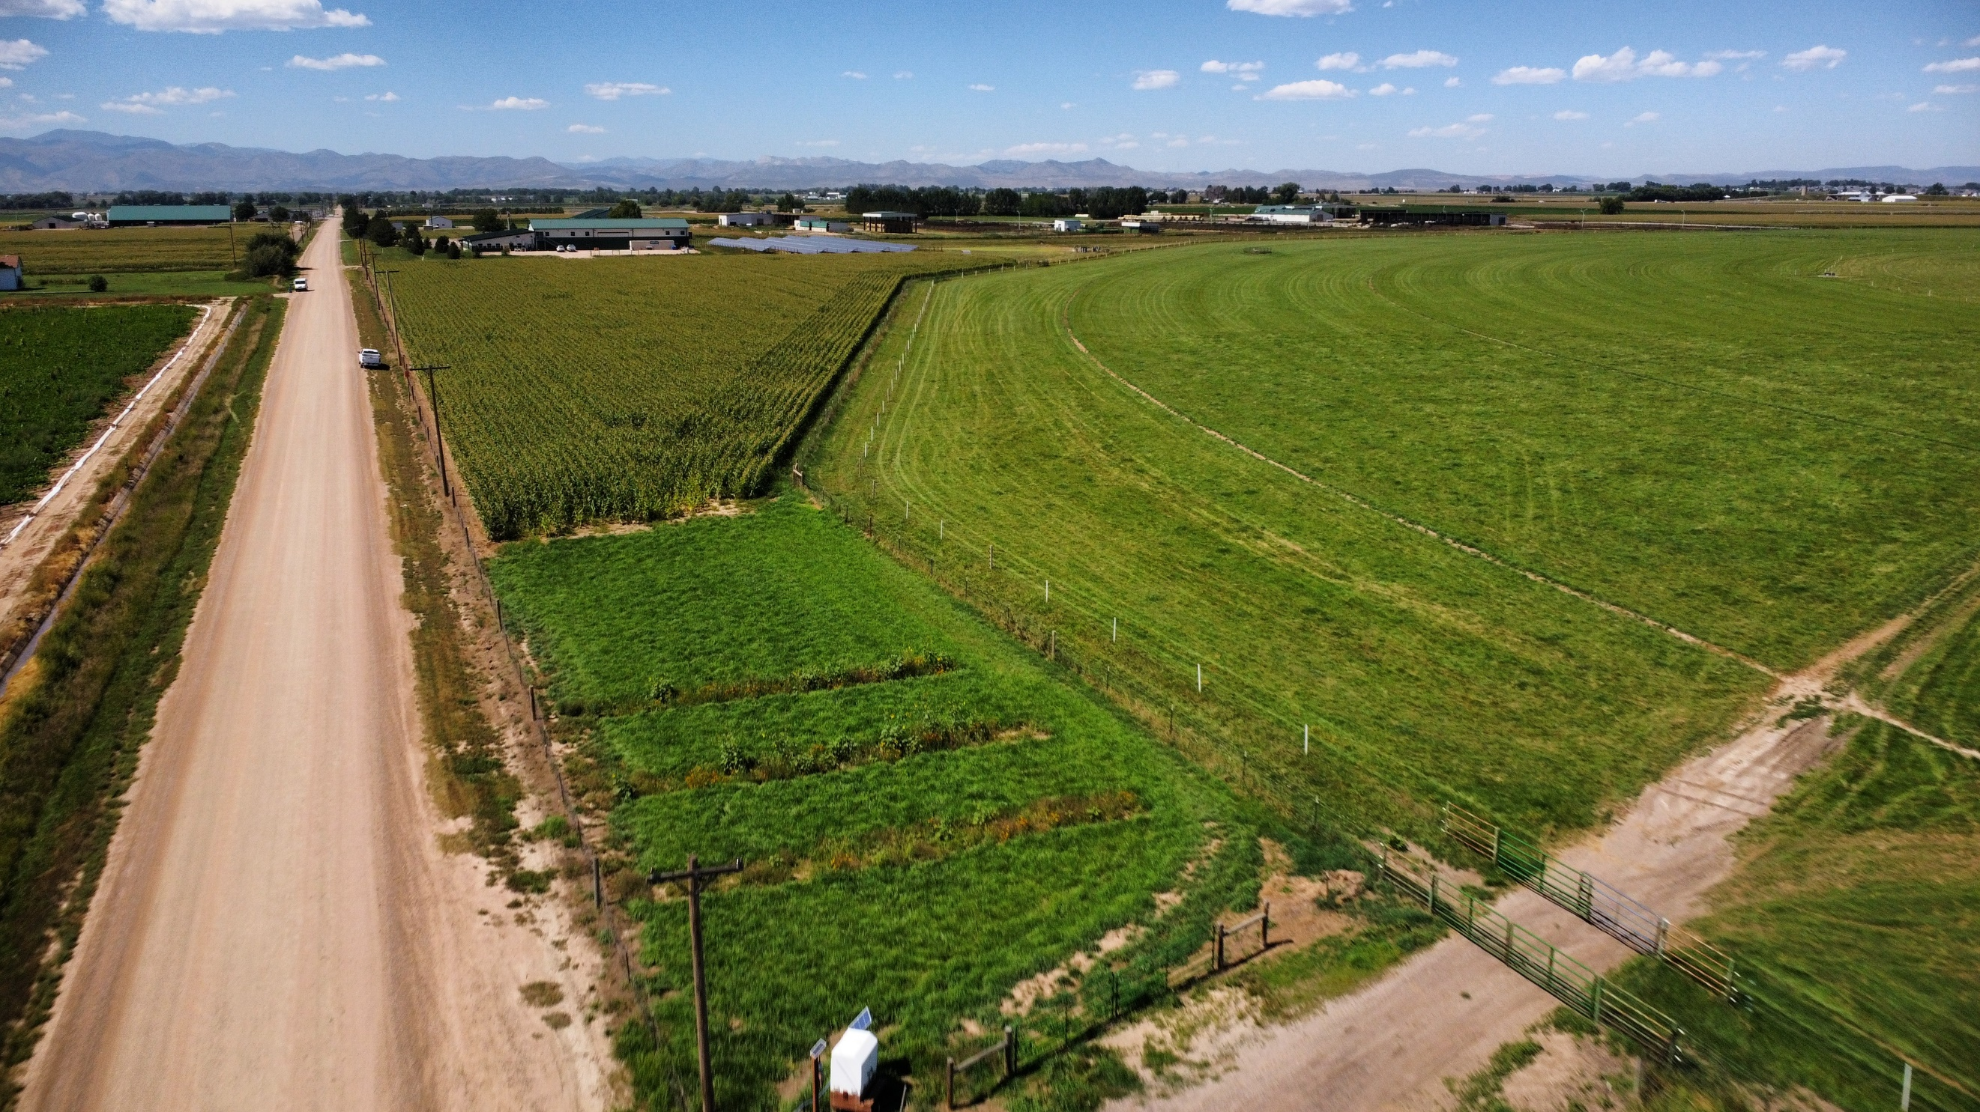

# Final report: 15 december 2023

### Erik Wardle, A.J. Brown, Emmanuel Deleon, Christina Welch

2023

# Executive Summary

The Colorado Corn Council provided funding for the project “Establishing Pollinator Habitats in Vegetative Filter Strips: A Sustainable Opportunity for Colorado Corn Farmers” conducted by the Colorado State University (CSU) Agriculture Water Quality Program (AWQP).

The AWQP mission is to protect Colorado state waters from degradation due to the improper use of agricultural chemicals while allowing for their proper and correct use. The AWQP conducted a pilot project to create a pollinator habitat in an existing vegetative filter strip located at the tail end of a surface irrigated grain corn field. The primary project goal was to investigate the potential of establishing pollinator species in an existing filter strip and measure the impact the pollinator species has on nutrient and sediment removal in relation to runoff water quality. By comparing water nutrient concentrations over years pre- and post- pollinator establishment, it was possible to quantify how the filtering capacity of the vegetative buffer strip was impacted.

This final report summarizes the project objectives, methods, results, conclusions, and opportunities for future research.

# Background and Objective

Colorado corn producers have long recognized the need to utilize practices that benefit both economic and environmental sustainability. In fact, many Colorado corn growers are already using a diverse set of practices that better match the nutrient needs of the crop, reduce environmental impacts, and increase profitability.

Irrigation and intensive rainfall events can cause surface runoff and deep leaching from agricultural fields resulting in loss of valuable nutrients, nitrogen (N) and phosphorus (P). Non-point sources of pollution like these are being considered as the State of Colorado begins to implement nutrient criteria ([Regulation 85](https://coagnutrients.colostate.edu/)) for surface water in addition to continued monitoring of nutrients and pesticides in groundwater.

One best management practice (BMP) for reducing nutrient and sediment loss in surface runoff is the use of vegetative filter/buffer strips (NRCS Conservation Practices Standard no. 393). These are areas of perennial vegetation, planted at the edge of an agricultural field, which can help remove nutrients and sediment from tail water. Filter strips are designed to move runoff water across the strip, filtering sediment and nutrients before the water leaves a field. Potential benefits of VFSs include reduction of sediment and nutrients and E coli in runoff, improving water quality and potentially increasing soil health.

Although there is a body of research on the effectiveness of filter strips in agronomic systems in the Midwest, there is a lack of information in the Intermountain West. Additionally, little research has been done to investigate the potential for pollinator habitats in filter strips. More than 30 percent of food production relies on insect pollination, mainly bee species. The annual value of crops pollinated by wild, native bees in the United States is estimated at $3 billion. Recent research has shown that wild native bees, which number more than 4,000 species in North America, contribute substantially to crop pollination on farms where their habitat needs are met (USDA Biology Technical Note No. 78, 3rd Ed.). As such, it is increasingly important that farmers implement practices to promote habitat for these crucial pollinators.

This project addressed the following Colorado Corn Council (CCC) priority areas:

* *Soil Health, Sustainability, & Carbon*: Encourages the adoption of conservation practices that provide environmental and societal benefits while enhancing producer profitability.
* *Water*: Improved water management; conservation, efficiency, quality, monitoring
* *Production Resources*: Nutrient management efficiency, practical application, and use of data results

# Methodology

## Study Site: CSU ARDEC

In 2020 a filter strip, approximately 0.25 acres in size, was established at the tail edge of a 5.5-acre field at CSU’s Agricultural Research, Development and Education Center (ARDEC) near Fort Collins. This filter strip contained meadow brome and orchardgrass and has successfully reduced significant issues with sediment runoff, and nutrients. The crop rotation for the study field is corn, pinto beans, and winter wheat. The field is furrow irrigated utilizing gated pipe and well water. In 2022, the field was planted to grain corn utilizing appropriate fertilizer BMPs.

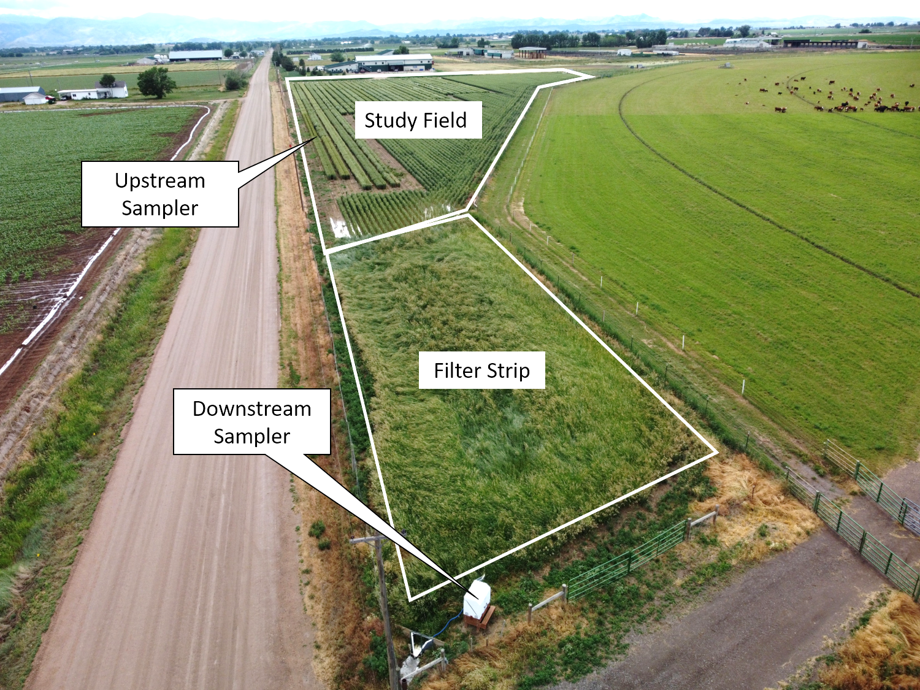

Figure 1. Study field and filter strip layout with automated sampler locations highlighted. A short (90 sec.) video tour of the site can be found here: <https://www.youtube.com/watch?v=O2kjEdDUdSU\>

## Water Sample Collection

The AWQP already installed automated water sampling devices both upstream and downstream of the existing filter strip to measure important water quality parameters (including; Nitrate, Nitrite, Total Phosphorus, Total Kjeldahl Nitrogen, Total Suspended Solids, Orthophosphate, Electrical Conductivity, Total Dissolved Solids, and pH), and subsequently quantify the effectiveness of the filter strip to reduce the pollutant concentration of the analytes listed above. Each sampling device consists of a flume to measure water flow, A Teledyne ISCO 6712 portable water sampler, a bubbler unit to measure water depth within the flume, a cellular modem, and a solar-powered 24V battery.

During each irrigation event, these automated samplers collected 200 mL water each hour that went into a 4 L bottle for compositing. During storm events, the equipment sampled based on flow intensity at 200 mL of water per 250 gal of water through the flume, which were also composited into 4 L bottles. Composite samples were removed and processed after an irrigation or storm event within 48 hours to meet hold times for water quality analysis. Methods used to characterize each analyte can be found in Table 1.

Table 1. List of water analytes characterized, and corresponding lab methods used.

|  |  |
| --- | --- |
| **Water Analyte** | **Lab Method** |
| Nitrogen, Nitrate (As N) | EPA 300 |
| Nitrogen, Nitrite (As N) | EPA 300 |
| Nitrogen, Total Kjeldahl | M4500 |
| Phosphorus, Total (As P) | SM4500P E |
| Phosphorus, Total Orthophosphate (as P) | SM4500P E |
| Selenium, Total | EPA 200.8 |
| Specific Conductance | EPA 120.1 |
| Suspended Solids (Residue, Non-Filterable) | EPA 160.2 |
| Total Dissolved Solids (Residue, Filterable) | EPA 160.1 |
| pH | EPA 150.1 |

These sampling methods were used to collect water quality in 2021 (pre-pollinator establishment), 2022 (failed-establishment/bare ground), and 2023 (full-establishment). This allowed for comparisons between years and observing any impacts on water quality as a result of pollinator establishment.

## Establishing Pollinator Species

In 2022, the AWQP team planted a mix of pollinator plants to the established filter strip. It was determined after discussing with local seed dealers, and cross checking against [CSU Extension Fact Sheet 5.616](https://extension.colostate.edu/topic-areas/insects/creating-pollinator-habitat-5-616/), the “PBSI Native Prairie Wildflower Mix” from Pawnee Buttes Seed, Inc. (Greeley, CO), was the ideal seed mix to use for this study. This mix contained the following species: Blue Aster, Illinois Bundleflower, Indian Blanket, Leadplant, Maximillian Sunflower, Narrowleaf Penstemon, Oxeye Sunflower, Partridge Peas, Prairie Cinquefoil, Showy Evening Primrose, Canada Milkvetch, Annual Sunflower, Black-eyed Susan, Blanketflower, Plains Coreopsis, Purple Prairie Clover, Upright Prairie Coneflower, Western Yarrow, and Scarlet Globemallow. These species comprise a variety of early, mid, and late season pollinator plants to ensure that vegetative growth existed in the filter strip through most of the growing season.

### No-Cost Extension in 2023

After the field season ended 2022, the AWQP was granted a no-cost extension for this project to complete the deliverables by 12/31/2023. The justification for this request was due to the poor establishment of pollinator species in the filter strip.

After planting the pollinator species in May 2022 (inter seeded into mowed perennial grass) regular checks were made for gemination and emergence. Due to competitive pressure from the grass and dry conditions, a stand of the pollinator species was not well established. By September it was decided to rototill three strips in the grass and establish a cover crop in those strips to better prepare the ground for a successful establishment in 2023 (Figure 2).

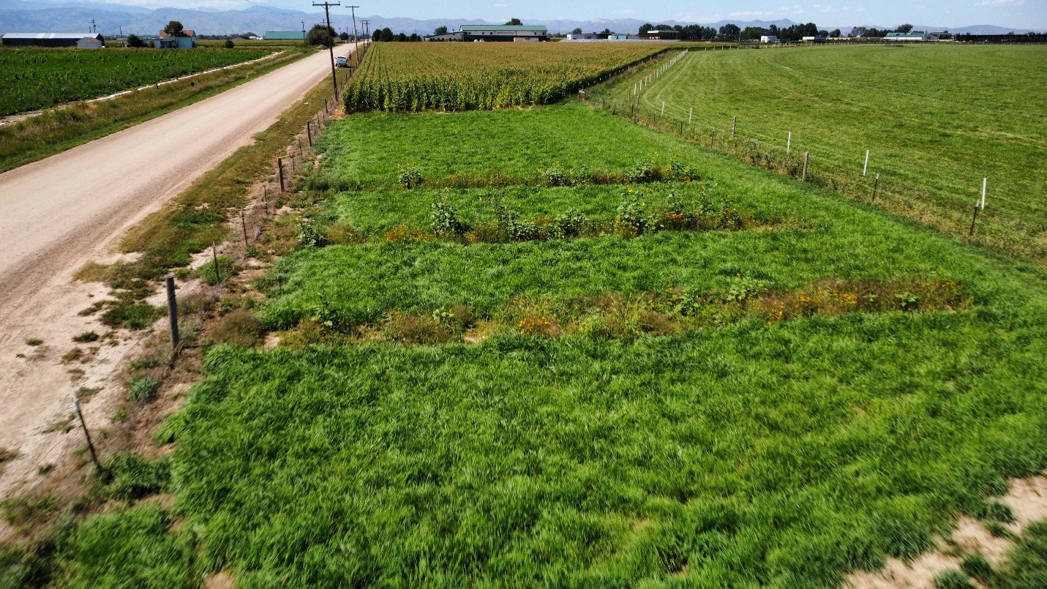

Figure 2. Arial view of the vegetative filter strip with three established transects were planted with pollinator species after rototilling, fall cover crop establishment, and spring hand seeding and transplanting of pollinator species.

In September 2022, a fall cover crop mix was sown by hand at 80 lbs. / ac. using a hand spreader and garden rakes. The mix chosen was the “Fall/Winter Cover Crop Mix” from Pawnee Butte Seed Inc. which included: Winter Peas, Winter Rye/Triticale, Turnips, Hairy Vetch, Radish, and Dwarf Essex Rape. In early spring 2023 the cover crop was terminated, and pollinator species was hand-sewn in the strips at the same recommended rate as previously. Furthermore, to ensure that pollinator species would be established in 2023, seed trays were planted in early June containing the pollinator seed mix for transplanting in mid-July.

## Data Analysis

Data collected during 2021, 2022, and 2023 was used to determine the ability of the filter strip to remove pollutants by creating an efficiency percentage that compares inflow and outflow concentrations of water analytes over years:

$R_{y, c}=\frac{\overline{I_{y,c}}-\overline{O_{y,c}}}{\overline{I_{y,c}}}×100$ (1)

Where $R_{y,c}$ is the annual removal efficiency, $\overline{I_{y,c}}$ is the average annual inflow analyte concentration, $\overline{I_{y,c}}$ is the annual outflow analyte concentration; all for year, *y*, and analyte, *c*.

# Results and Discussion

## Pollinator Establishment

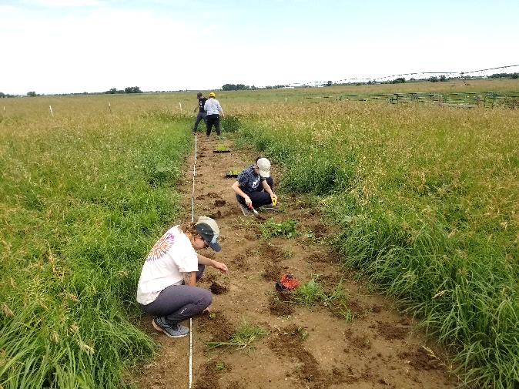 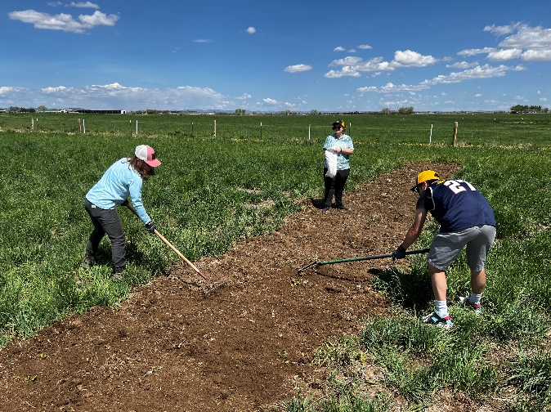 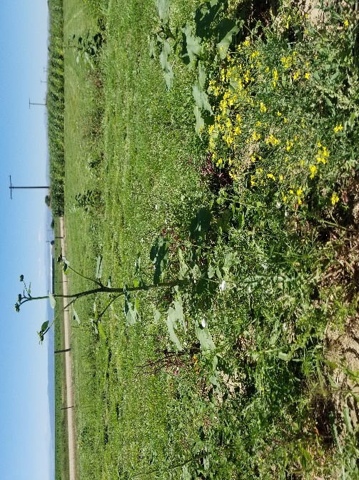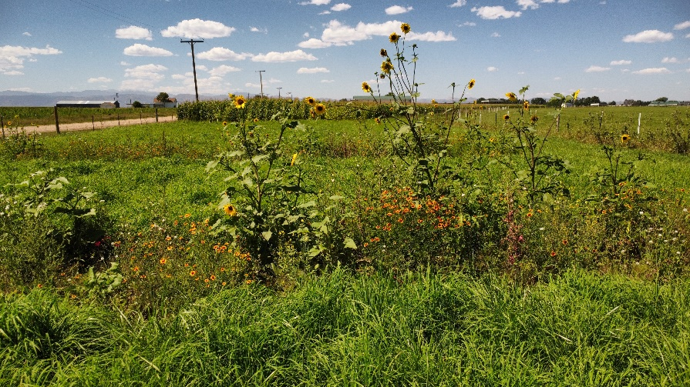

Figure 3. (Top Left) CSU AWQP Students transplanting pollinator species plugs into a rototilled seedbed. (Top Right) CSU AWQP students hand-sewing pollinator species seed with garden rakes. (Bottom Left) Image of the fall cover crop plants growing in spring 2023. (Bottom Right) Image of the pollinator species flowering in late summer 2023.

The proposed method for pollinator establishment worked well in 2023 after learning lessons from a failed establishment in 2022. The following method is proposed for future efforts to establish pollinator species in vegetative filter strips:

1. Rototill an area within the established filter strip in the early fall.
2. Seed a fall cover crop mix into the prepared seedbed in mid-late fall.
   1. Irrigate if necessary.
3. Rototill cover crop into the seedbed in late spring.
4. Hand or drill pollinator species seed mix in the early summer.
   1. Irrigate if necessary.
   2. Establish plugs in seed trays as a backup measure.
5. (Only if necessary) Transplant plugs into seedbed in mid-summer.

One of the key aspects of this project and methodology is the emphasis on adequate seed bed preparation for the pollinator species. It was found that those types of native flowering species could simply not outcompete the established perennial grasses found in the filter strip. Furthermore, the subsidized slow establishment of pollinator species with transplanted plugs, however, in real application, this might be impractical. As such, it would be more realistic to allow at least a full year for the pollinators to establish, allowing the seedbed to fill out.

## Water Quality

Water quality data for each analyte are presented across three years: 2021, which offers insight into the filtering capacity before pollinator establishment; 2022, demonstrating the effects of bare, rototilled ground within the filter strip on water quality; and 2023, revealing the impact of fully established pollinator species on filtering capacity.

It is worth noting that results are presented in terms of analyte concentration (e.g., mg/L or ppm) and not in load (e.g., kg/ha or lbs./ac.). This is due to two main factors:

1. The inflow water was only able to collected from two irrigated furrows, not the entire study field, due to the equipment setup and feasibility of water capture without dramatically changing the runoff water pathways.
2. The filter strip has a soil berm around it that is supposed to keep water within the strip, however, in 2022 and 2023, a breakover occurred that was not repaired in time for irrigation season. This prevented the team from capturing all runoff from the study field after the filter strip.

As such, reasonable comparisons could only be made in terms of concentration, which would not hinder the ability to calculate filtering capacity as previously shown in Equation 1.

### Phosphorous and Total Suspended Solids

Most runoff water quality impacts were seen in phosphorous (P) and soil erosion (i.e., total suspended solids; TSS) qualities. Specifically, in 2021, total P values were low (< 1 mg/L) in the observed runoff, but increased in 2022 after disturbing the soil to values above 1 mg/L. However, after the pollinators were established in 2023, the resulting total P and TSS values were back to near normal levels (Figure 4). Little difference was seen in concentrations of orthophosphate (OP) between inflow and outflow over 2022 and 2023, which is suspected to be due to the increased solubility of OP. Because OP is highly soluble, it tends to flow through filter strips without much potential for removal.

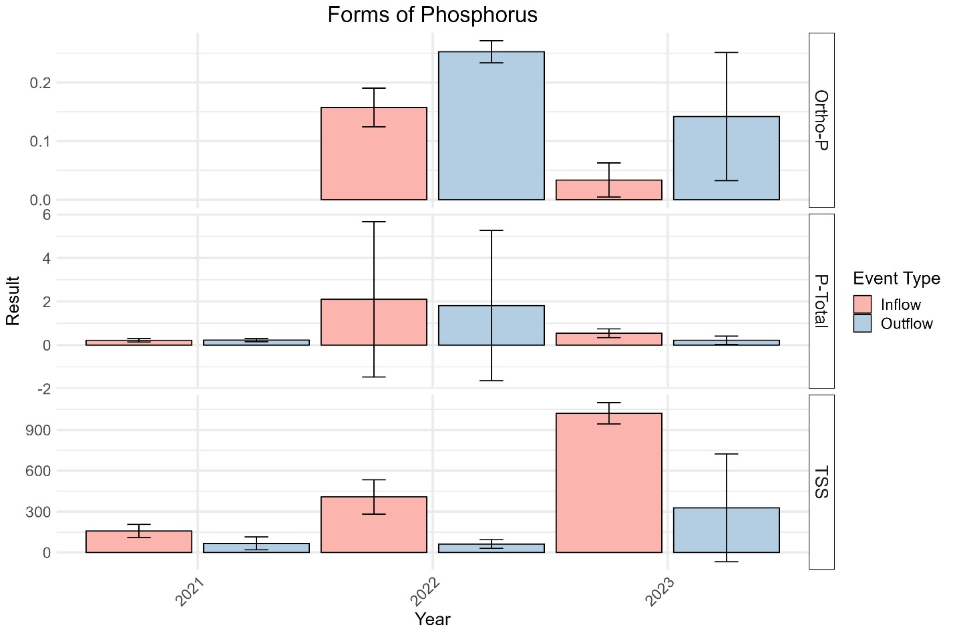

Figure 4. Bar graph comparing annual average concentrations of orthophosphorous (Ortho-P; mg/L), total phosphorous (P-Total; mg/L), and total suspended solids (TSS; mg/L) in the inflow (pink bars) and outflow (blue bars) waters in relation to the vegetative buffer strip established at the study site. Error bars represent the standard deviation of the average.

### Nitrogen

Three forms of nitrogen were observed over the 2021 – 2023 study period. Nitrite-N (NO2), Nitrate-N (NO3), and Total Kjeldahl Nitrogen (TKN). NO2 is an anerobic form of N that’s rarely found in surface water because of a normal abundance of oxygen at the water-air boundary. However, it was detected once in 2022, likely due to excess ponding and slow water velocity in the filter strip. NO3 is a more common form of N found in surface water, as it is a soluble form that occurs when oxygen is present, and can come from many sources such as agricultural chemicals, manure, or fertilizer. It was detected over all three years in both inflow and outflow waters. Taking into account the larger standard deviations around the NO3 means, very little change was observed. TKN is a way to quantify organic forms of N that are typically coming from crop residue and manures. TKN nitrogen often adheres to filter strips, but in our case, TKN increased in 2023, but only one sample was collected so this trend cannot be statistically supported.

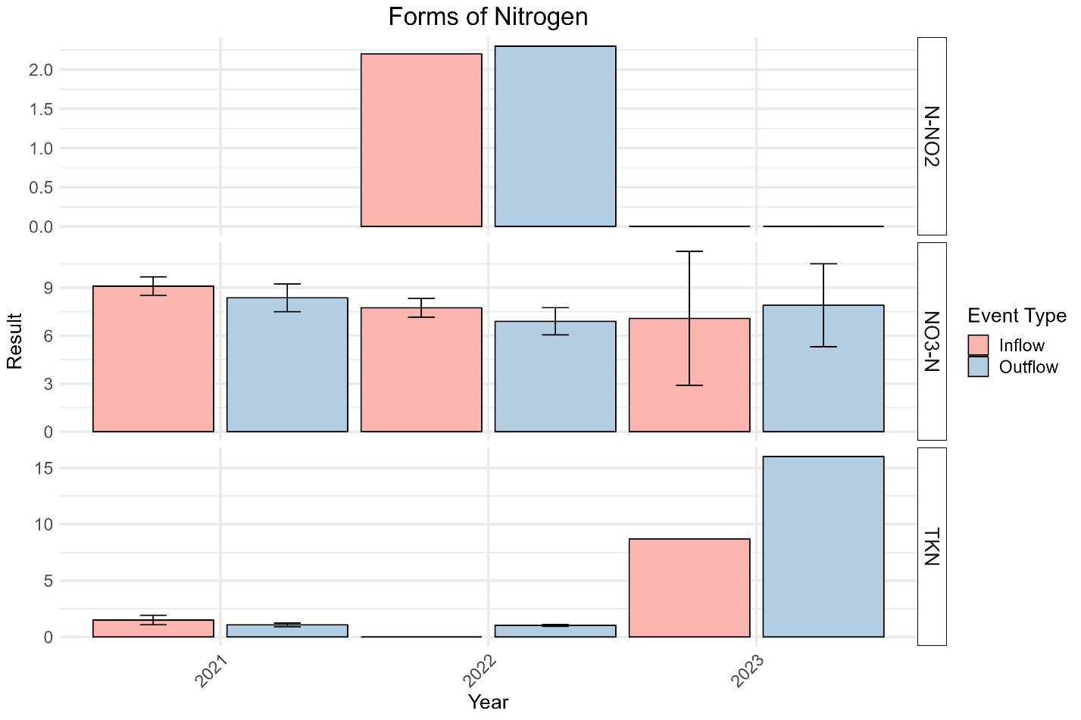

Figure 5. Bar graph comparing annual average concentrations of nitrogen, nitrate (N-NO2; mg/L), nitrogen, nitrate (NO3-N; mg/L), and total Kjeldahl nitrogen (TKN; mg/L) in the inflow (pink bars) and outflow (blue bars) waters in relation to the vegetative buffer strip established at the study site. Error bars represent the standard deviation of the average.

### Other Analytes

The remaining analytes tested were specific conductivity (EC; dS/m), pH, Selenium (Se; mg/L), and total dissolved solids (TDS; mg/L). None of these analytes were tested over all three study years, however, they are presented regardless to provide a baseline for future studies. EC values observed were relatively low, indicating no serious salinity threat. pH values were relatively high (approximately 8), likely due to large amounts of carbonate/lime found in the study field soils. Se values were relatively consistently low over both 2021 and 2022. TDS was relatively high compared to what might be expected based on the salinity estimate from the annual average EC values being < 0.3 dS/m. This also indicates that carbonate/lime might be present in solution, as it can be very large in atomic size, but not contribute much to solution conductivity.

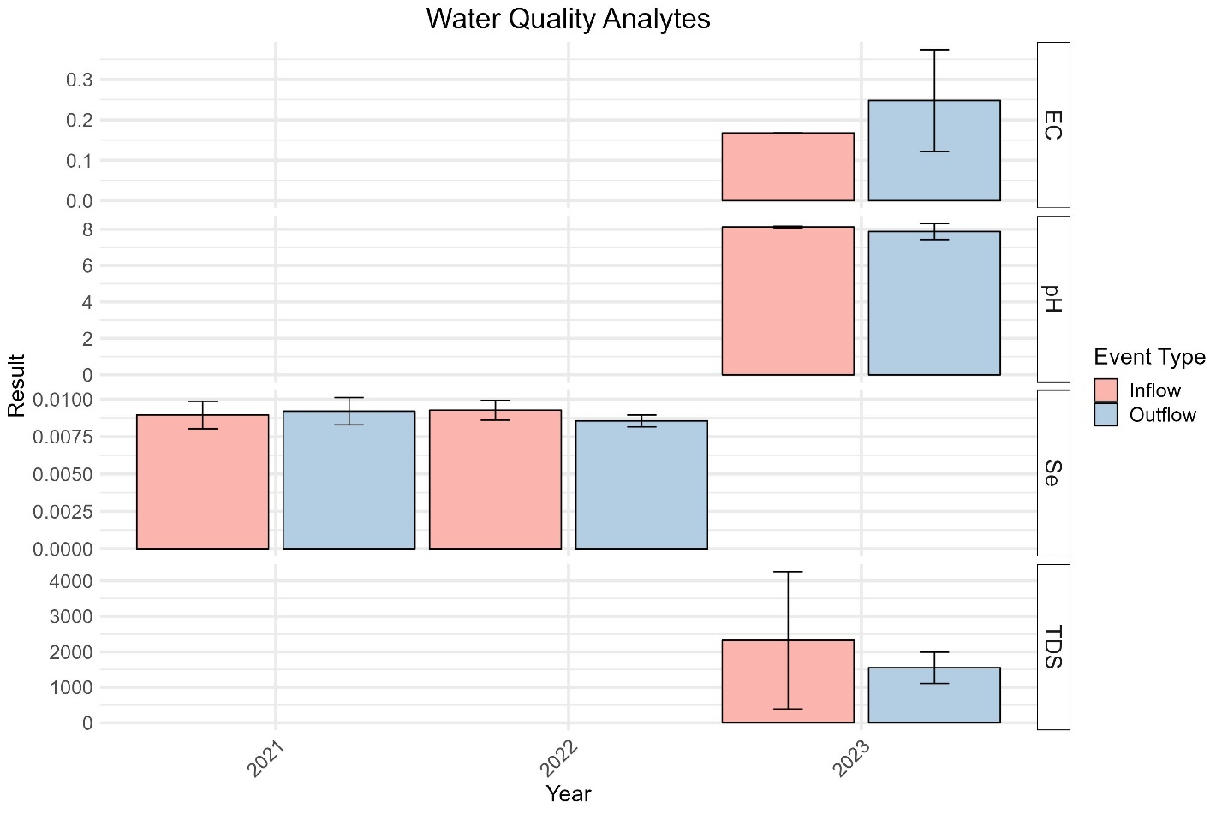

Figure 6. Bar graph comparing annual average specific conductivity (EC; dS/m), pH, concentrations of selenium (Se; mg/L) and total dissolved solids (TDS; mg/L) in the inflow (pink bars) and outflow (blue bars) waters in relation to the vegetative buffer stri.

### Calculating Removal Efficiency

Using Equation 1 from the Data Analysis section above, removal efficiency (R%) was calculated for analytes where data was available for all three years of the study for accurate comparison and placed in Table 2. Additionally, these analytes (NO3-N, TKN, Total-P, and TSS) tend to be some of the more critical analytes for characterizing runoff water environmental impacts.

Table 2. Calculation of removal efficiency (%) for NO3-N, TKN, Total-P, and TSS water analytes over the 2021, 2022, and 2023 study years. Also shown are the annual average inflow and outflow concentrations. Standard deviation around each average is shown in parentheses next to the average.

|  |  |  |  |  |
| --- | --- | --- | --- | --- |
| **Analyte** | **Year** | **Inflow Concentration**  **Mean (Std)**  **mg/L** | **Outflow Concentration**  **Mean (Std)**  **mg/L** | **Removal**  **Efficiency**  **%** |
| Nitrogen,  Nitrate (As N) | 2021 | 9.1 (0.58) | 8.4 (0.87) | 8.0 |
| 2022 | 7.7 (0.58) | 6.9 (0.85) | 10.9 |
| 2023 | 7.1 (4.19) | 7.9 (2.6) | -11.5 |
| Nitrogen,  Total Kjeldahl | 2021 | 1.5 (0.42) | 1.1 (0.16) | 28.5 |
| 2022 | 0 (0) | 1 (0.09) | NA |
| 2023 | 8.7 (0) | 16 (0) | -83.9 |
| Phosphorus,  Total (As P) | 2021 | 0.2 (0.08) | 0.2 (0.07) | -2.7 |
| 2022 | 2.1 (3.56) | 1.8 (3.45) | 13.7 |
| 2023 | 0.5 (0.2) | 0.2 (0.19) | 59.2 |
| Suspended Solids  (Residue, Non-Filterable) | 2021 | 157.5 (48.56) | 66.7 (47.11) | 57.7 |
| 2022 | 408 (125.91) | 61.7 (31.95) | 84.9 |
| 2023 | 1021.7 (77.78) | 327.8 (396.03) | 67.9 |

For NO3-N, the R% increased from 2021 to 2022 (8.0 % to 10.9 %) but decreased dramatically in 2023 (-11.5). However, these trends are likely statistically insignificant due to the large standard deviations around each mean, which can also be seen in the previous Figure 5. *These results indicate that establishing pollinator strips had very little, to a slightly negative impact on NO3-N filtering capacity within the filter strip.*

For TKN, the R% was 28.5 % in 2021, but could not be calculated in 2022 because no TKN was found in the inflow water that year. In 2023, the removal efficiency decreased to -83.5 %, indicating that the filter strip was contributing to TKN water concentrations. However, these results are very uncertain, as the 2023 results only had a single water sample, resulting in a lack of any standard deviation. *Because of this, we are not confident in saying that the filter strip is contributing TKN to the runoff water without additional results.*

For Total P, the R% increased over all study years (-2.7 % in 2021, 13.7 % in 2022, and 59.2 % in 2023). However, there were significant standard deviations around these means, making the overall trend uncertain. *However, these results indicate that establishing pollinator species in the filter strip had little effect to a very positive effect on its ability to reduce total P concentrations.*

For TSS, the R% remained relatively steady over all study years after considering the large standard deviations around the average concentrations in inflow and outflow waters (57.7 % in 2021, 84.9 % in 2022, and 67.9 % in 2023). *These results suggest that establishing pollinator species did not have a negative or positive impact on the filter strip’s ability to remove sediment from runoff water.*

# Conclusion

The "Establishing Pollinator Habitats in Vegetative Filter Strips" project, funded by the Colorado Corn Council and conducted by Colorado State University's Agriculture Water Quality Program (AWQP), has provided valuable insights into sustainable agricultural practices for in Colorado. This initiative aimed to investigate the impact of pollinator species on the nutrient and sediment removal capabilities of vegetative filter strips in surface runoff water quality.

Our data analysis, utilizing inflow and outflow water samples collected over three years (2021-2023), revealed significant findings regarding the effectiveness of these filter strips. We employed techniques to calculate the removal efficiency of various analytes, including Nitrogen, Phosphorus, and soil erosion (i.e., Total Suspended Solids), thereby assessing the filtering capacity of the vegetative buffer strip. Results indicate that the introduction of pollinator species within the filter strips has varying effects on water quality parameters. Notably, Total Phosphorus and Total Suspended Solids showed a return to near-normal or better than previous levels in 2023 after the full establishment of pollinator species, underscoring the potential benefits of such ecological interventions. However, the impact on Nitrogen forms was less definitive, due to their increased solubility.

One of the critical learnings from this study was the importance of proper seedbed preparation and timely irrigation for the successful establishment of pollinator species. The challenges encountered in 2022 due to competition from existing grass and dry conditions highlighted the need for a well-planned approach to ensure effective establishment and growth of pollinator species. The adaptive measures taken in 2023, including rototilling and the introduction of cover crops, significantly improved the establishment process.

In conclusion, these findings demonstrate that establishing pollinator habitats within vegetative filter strips can be a feasible and beneficial practice for Colorado corn farmers, enhancing both ecological and agricultural sustainability. The lessons learned provide valuable guidance for future efforts in similar contexts, advocating for a balanced approach that considers both agricultural productivity and environmental stewardship.

The AWQP recommends further research to refine the techniques and practices for establishing pollinator species in filter strips, focusing on the nuanced interactions between agricultural practices and ecological enhancements. Additionally, future work could characterize pollinator fauna presence after plant establishment. As the State of Colorado continues to implement nutrient criteria for surface water, such practices could play a significant role in achieving sustainable agricultural goals while simultaneously protecting water quality.

# Acknowledgements

The CSU AWQP would like to thank the Colorado Corn Council for their support in this study, especially by providing a no-cost extension so that quality data could be collected for robust conclusions. Additionally, we acknowledge the support of the Colorado State University (CSU) Agriculture Research, Development and Education Center (ARDEC) and Agricultural Experiment Station (AES) for providing the research site and farm management around the study area.

